**2019103573 CN LAB - 13 SACHIN RAGHUL T**

**CYCLIC REDUNDANCY CHECK - CRC**

**SERVER :**

**#include <stdio.h>**

**#include <string.h>**

**#include <sys/types.h>**

**#include <sys/socket.h>**

**#include <netinet/in.h>**

**#include <netdb.h>**

**#define SERV_TCP_PORT 3573**

**int main(int argc, char **argv)**

**{**

**int sockfd, newsockfd, clength;**

**struct sockaddr_in serv_addr, cli_addr;**

**char a[30], b[30], c[30] = {0}, q[30] = {0}, p[30] = {0}, np[30] = {0}, crc[10] = {0}, r[30] = {0};**

**int n, m, i = 0, j = 0, count = 0, k = 0, l = 0, ir = 0, ip = 0, cou = 0, u = 0, w = 0, nk = 0;**

**sockfd = socket(AF_INET, SOCK_STREAM, 0);**

**serv_addr.sin_family = AF_INET;**

**serv_addr.sin_addr.s_addr = INADDR_ANY;**

**serv_addr.sin_port = htons(SERV_TCP_PORT);**

**printf("\n Binded...");**

**bind(sockfd, (struct sockaddr *)&serv_addr, sizeof(serv_addr));**

**listen(sockfd, 5);**

**clength = sizeof(cli_addr);**

**newsockfd = accept(sockfd, (struct sockaddr *)&cli_addr, &clength);**

**read(newsockfd, a, 30);**

**read(newsockfd, b, 30);**

**m = strlen(b);**

**printf("\n Dividend:%s", a);**

**printf("\n Divisor:%s", b);**

**strcpy(c, a);**

**for (i = 0; i < m - 1; i++)**

**strcat(c, "0");**

**printf("\n Dividend with zero appended:%s", c);**

**for (i = 0; i < m; i++)**

**{**

**p[k++] = c[i];**

**if (strlen(p) == m)**

**q[j++] = 'l';**

**}**

**for (i = 0; i < strlen(c);)**

**{**

**if (p[nk++] == b[l++])**

**r[ir++] = '0';**

**else**

**r[ir++] = 'l';**

**Count++;**

**if (count == strlen(b) && i < (strlen(c) - 1))**

**{**

**ip = 0;**

**for (u = 0; u < strlen(b); u++)**

**{**

**if (r[u] == 'l')**

**{**

**for (n = u; n < strlen(b); n++)**

**{**

**np[ip++] = r[n];**

**r[n] = '0';**

**cou++;**

**}**

**}**

**}**

**count = 0;**

**nk = 0;**

**l = 0;**

**ir = 0;**

**if (cou != strlen(b))**

**{**

**if ((strlen(b) - cou) == (strlen(c) - (i + 1)) || (strlen(b) - cou) < (strlen(c) - (i + 1)))**

**{**

**while (cou != strlen(b))**

**{**

**i++;**

**np[ip++] = c[i];**

**cou++;**

**W++;**

**}**

**strcpy(p, np);**

**for (u = 0; u < w - 1; u++)**

**q[j++] = '0';**

**if (w != 0)**

**{**

**i -= strlen(np);**

**w = 0;**

**}**

**}**

**else**

**{**

**for (; i + 1 < strlen(c);)**

**{**

**i++;**

**np[ip++] = c[i];**

**w++;**

**}**

**if (ip < strlen(b))**

**{**

**for (; ip < strlen(b);)**

**np[ip++] = ' ';**

**}**

**strcpy(r, np);**

**for (u = 0; u < w - 1; u++)**

**q[i++] = '0';**

**i = strlen(c);**

**w = 0;**

**}**

**}**

**if (cou = strlen(b))**

**{**

**q[j++] = 'l';**

**cou = 0;**

**}**

**ip = 0;**

**cou = 0;**

**}**

**i++;**

**}**

**printf("\n Quotient=%s", q);**

**printf("\n Remainder=%s", r);**

**for (i = strlen(r) - (m - 1); i <= strlen(r); i++)**

**crc[w++] = r[i];**

**printf("\n CRC values: %s\n", crc);**

**write(newsockfd, q, 30);**

**write(newsockfd, r, 30);**

**write(newsockfd, crc, 10);**

**close(sockfd);**

**return 0;**

**}**

**CLIENT :**

**#include<stdio.h>**

**#include<string.h>**

**#include<sys/types.h>**

**#include<sys/socket.h>**

**#include<netinet/in.h>**

**#include<netdb.h>**

**#define SERV_TCP_PORT 3573**

**int main(int argc,char * * argv)**

**{**

**int sockfd;**

**struct sockaddr_in serv_addr;**

**struct hostent *server;**

**char a[30],b[30],q[30],r[30],crc[10];**

**sockfd=socket(AF_INET,SOCK_STREAM,0);**

**serv_addr.sin_family=AF_INET;**

**serv_addr.sin_addr.s_addr=inet_addr("127.0.0.1");**

**serv_addr.sin_port=htons(SERV_TCP_PORT);**

**connect(sockfd,(struct sockaddr*)&serv_addr,sizeof(serv_addr));**

**printf("\nEnter the dividend:");**

**scanf("%s",a);**

**printf("\nEnter the divisor:");**

**scanf("%s",b);**

**write(sockfd,a,30);**

**write(sockfd,b,30);**

**printf("\n");**

**printf("\nServer result:");**

**read(sockfd,q,30);**

**read(sockfd,r,30);**

**read(sockfd,crc,10);**

**printf("\n\nQuotient=%s",q);**

**printf("\n\nRemainder=%s",r);**

**printf("\n\nCRC values=%s\n",crc);**

**close(sockfd);**

**return 0;**

**}**

**OUTPUT :**

**SERVER**



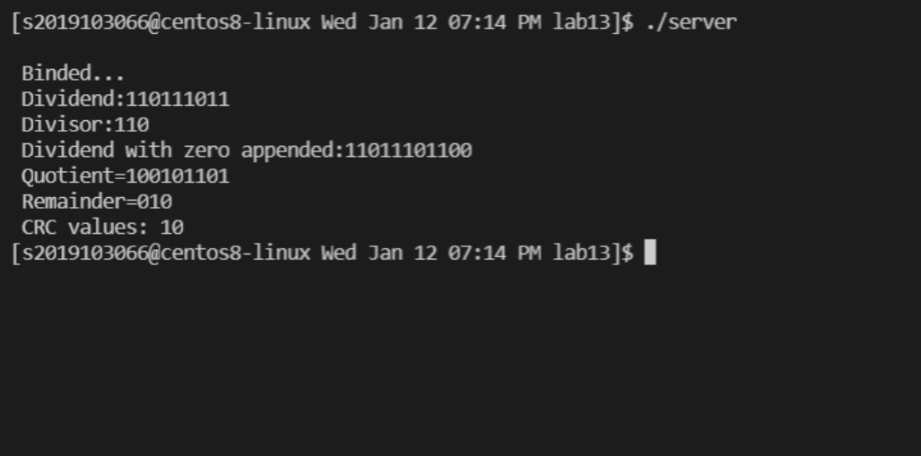

**CLIENT**



